Given a plane passing through origin therefore wT x = 0, and there is a one more vector P, so we have to find distance(d) of point P from plane pie and is given in fig below

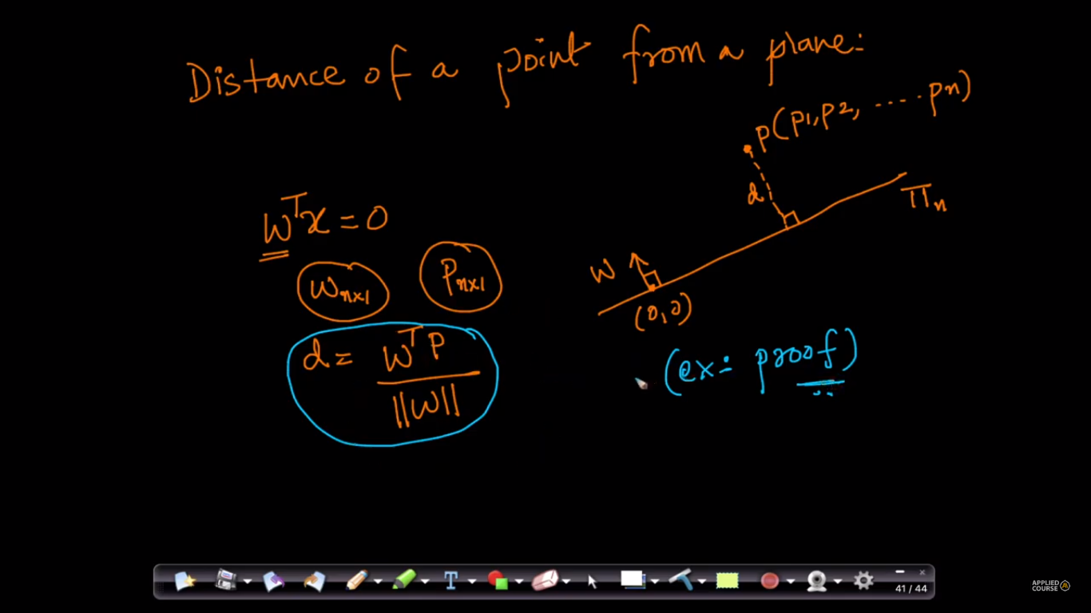

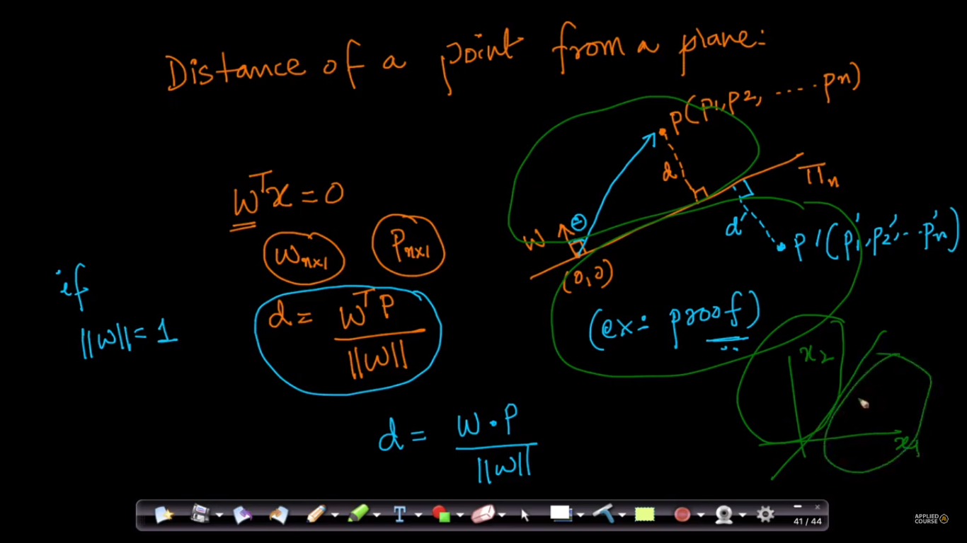

So why are we doing all these drawing plane, find a distance from new vector?

Because line or plane divide it into two half spaces, example for iris, it divides in two half spaces which states if point is above plane then it’s setossa otherwise not.

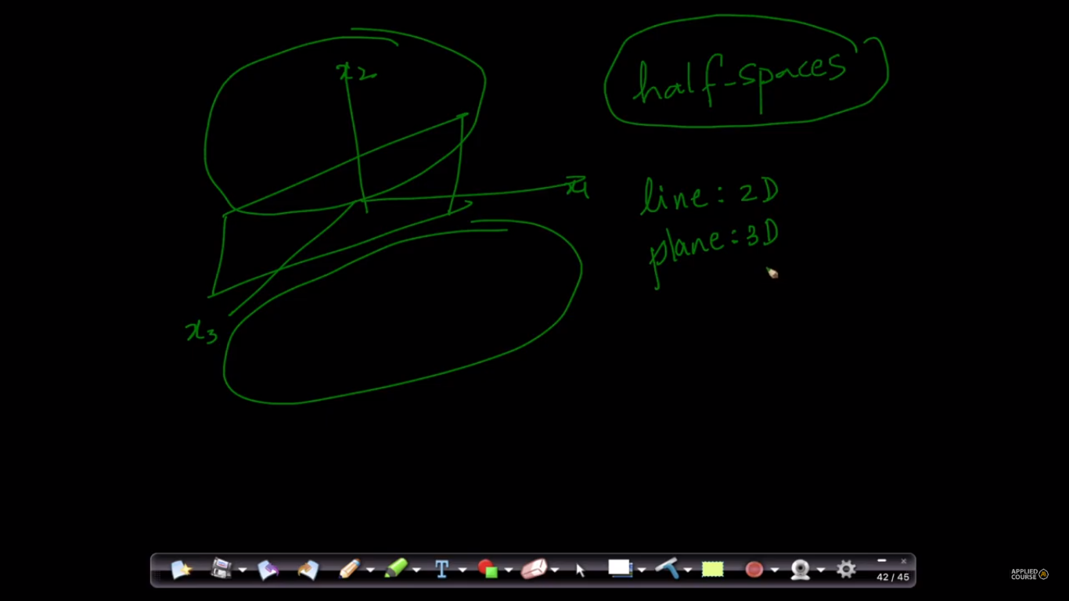

These two figure states the same thing as we have written above taking example of iris data set where one point is above plane and other is below plane